ASSIGNMENT 4

OSYS1200 – Introduction to Windows Administration

NSCC

Ricardo Oliveira

W0428722

Index

Introduction 2

Question or Research Section 2

Assignment questions 2

Works Cited 4

Script used in assignment 4

ICACLS Report/Screenshot 5

PDF of Change management 6

# Introduction

The purpose of this document is to answer any questions asked in the assignment as well as a means to display your change management log and any attachments or screenshots as required.

# Question or Research Section

## Assignment questions TASK 2

Part 2 (submit on Brightspace):

# What is the difference between ‘Account lockout duration’ and ‘Account lockout threshold’?

A: The duration is the determined time that the account stays locked, and the threshold, is the number of attempts of incorrect sign-ins before the account gets locked.

# How would you set an account to remain locked until the administrator unlocked it and why would you select this option?

A: By setting the lockout duration to 0, and this option would be selected to enforce the security policies of the client, by being sure that only the right user have access to that account.

# Why is it important to set Password and Account policies?

A: Because security is of the utmost importance to industry, business, studies, to information itself in general, and to have at least some certainty of who is accessing and how they`re doing it, you need to have Passwords and User Accounts, with its properties and policies.

## Assignment questions TASK 3

Research and create a report on the differences between Local, Roaming, Mandatory and Temporary Profiles in a Windows workstations. This report should be in the form of a summary table (example included below).

**Make sure to give**: a detailed description of the profile, the capabilities, associated files, uses and advantages/disadvantages of each type of profile.

|  |  |  |  |
| --- | --- | --- | --- |
| **Local Profile** | **Roaming Profile** | **Mandatory Profile** | **Temporary Profile** |
| Initial profile, created on the first time the user logs; The changes of it are specific to the user and to the computer; the files are stored on the computer`s local hd. | Copy of a local profile, stored on a server share; Can be download to any computer that a user logs onto on a network. Changes made to this profile are synchronized with the server copy of the profile at the log off, Advantage is that users don’t need to create a profile for each computer they use on a network. | Type of profile that administrators can use to specify settings for users, as only them can make the changes to these profiles. All the changes made by the users, at settings, are lost at the log off. | This profile is issued when an error condition prevents the user`s main profile from loading.  All temporary profiles are deleted at the end of each session, and the changes made by user to desktop settings, and even the files are lost at the log off.  The temporary profiles are available only on computers running windows 2000 and later. |
| The biggest disadvantage of having a local profile, is that, you really can`t, use it on a fruitful way on a business or industry scale network, if you have in mind that, you will need create a profile and configure all the desktop settings and software on each station. And it`s not a professional practice at the compliance/security standards. | It`s really a very good profile policy, it`s disadvantage is that, you often run into errors if the network isn`t correctly tuned. And the login process takes longer if the profile is big, since it needs to transfer the files over the network. | They`re difficult to create and they`re not that flexible for the user, since every change needs to be made by an admin. | They`re generated by error, and are completely temporary, you can only use them to access the resources, since you can`t use your previous configuration or software. |

# Works Cited

Microsoft. (2018, 04 29). Microsoft Docs. Retrieved from “About User Profiles” <https://docs.microsoft.com/en-us/previous-versions/windows/desktop/legacy/bb776892(v%3Dvs.85)>

# Script used in assignment

#Created On: 10/12/2019

#Author: Ricardo Oliveira

*:: A script that creates folders, a user, grants permissions and inheritance, copy program*

*:: put the new user into a group*

*::TURNS OFF THE PROMPT CURSOR*

@ECHO OFF

*::CLEAR SCREEN*

cls

*::CHANGE WINDOW TITLE*

title "ROliveira 1st Script Window"

*::CHANGE TO THE ROOT OF C*

c:

*::CREATE FOLDER SCRIPTS*

mkdir Scripts

*::CREATE USER CALLED ABRUCE WITH PASSWORD STUDENT*

net user ABruce student /add /fullname:"Aisha Bruce"

*::CHANGE TO ROOT OF E*

e:

*::GET INSIDE THE FOLDER MANAGEMENT*

cd CompanyInc\Management

*::CREATE NEW FOLDER*

mkdir "ABruce Files"

*:: SET PERMISSIONS TO FULL CONTROL AND INHERITANCE*

icacls "e:\CompanyInc\Management\ABruce Files" /grant "Abruce":(f) /inheritance:e /t /c

*:: COPY FILE INTO THE FOLDER*

copy C:\Windows\System32\cmd.exe "e:\CompanyInc\Management\ABruce Files\"

*:: GET USER INTO THE MANAGEMENT GROUP*

net localgroup Management ABruce /add

*::CREATING ICALCS REPORT*

icacls "e:\CompanyInc\Management\ABruce Files"* /save "c:\Scripts\icaclsReport.txt" /t

*:: COPY FILE INTO FOLDER*

move F:\NewUser.bat c:\Scripts\

PAUSE

## ICALCScript Report.txt

ABruce Files

D:AI(A;;FA;;;S-1-5-21-2820154595-1976357596-3937115071-1005)(A;OICIID;FR;;;S-1-5-21-2820154595-1976357596-3937115071-1002)(A;OICIID;0x1301bf;;;S-1-5-21-2820154595-1976357596-3937115071-1004)(A;OICIID;0x1200a9;;;S-1-5-21-2820154595-1976357596-3937115071-1003)(A;ID;FA;;;BA)(A;OICIIOID;GA;;;BA)(A;ID;FA;;;SY)(A;OICIIOID;GA;;;SY)(A;ID;0x1301bf;;;AU)(A;OICIIOID;SDGXGWGR;;;AU)(A;ID;0x1200a9;;;BU)(A;OICIIOID;GXGR;;;BU)

## ScreenShots

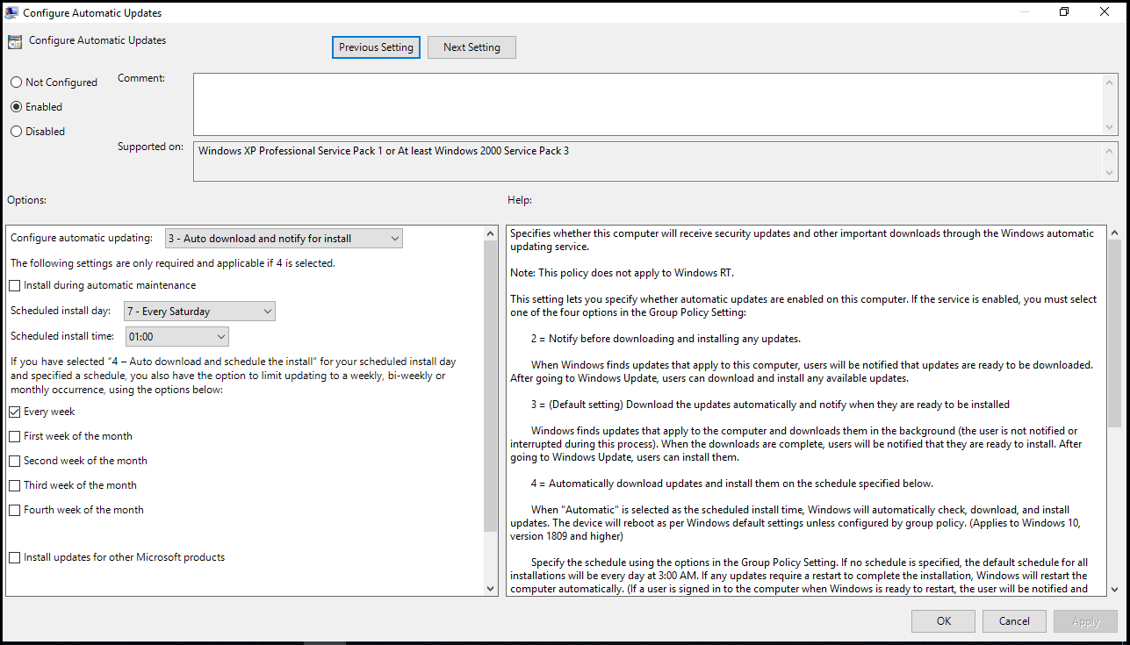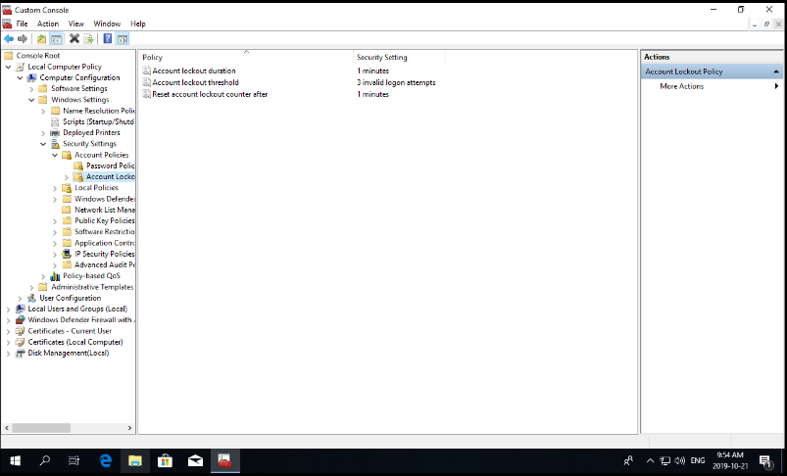

# PDF of Change management

